**I** **REVOLUTION :A DATA DRIVEN EXPLORATION OF APPLE**

**IPHONE IMPACT IN INDIA**

**1.INTRODUCTION**

1.1 Overview

*It dropped the physical keypad and introduced the single Home button at the front.* *The iPhone also brought the concept of apps on your smartphone. The best part was that you had a Safari browser to access the mobile internet* *as it was intended.*

1.2 Purpose

*While you're going about your day, you can use the apps on your iPhone to get directions, make purchases, and control accessories in your home. You can also silence notifications while you're driving or working, or allow only specific notifications related to what you're focused on.*

**2.PROBLEM DEFINITION and DESIGN THINKING**

2.1 Empathy Map

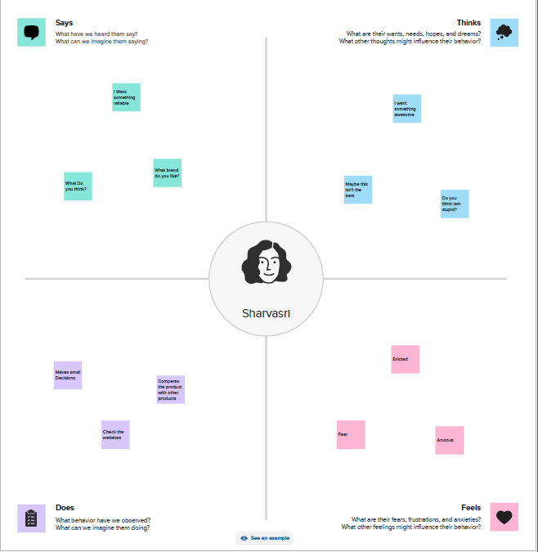

2.2 Ideation And Brain Storming Map

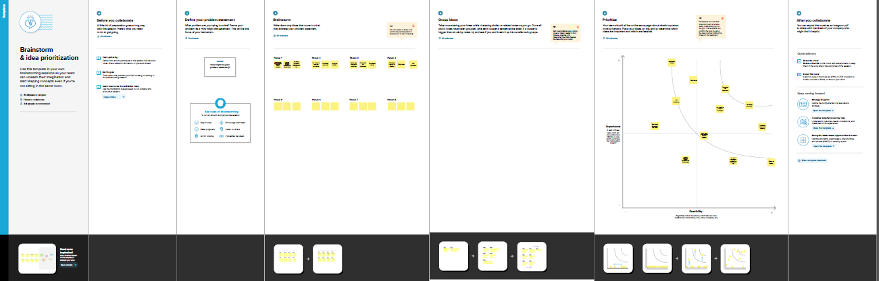

**3.RESULT**

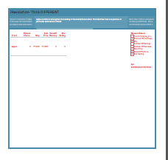

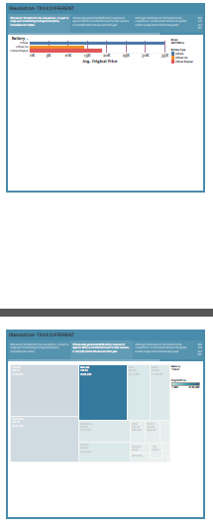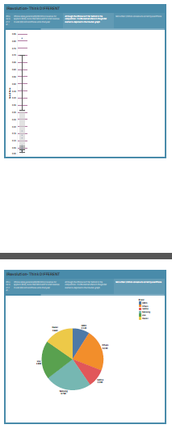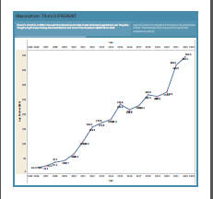

**4.ADVANTAGES And DISADVANTAGES**

Advantage:

* *#1Better Performance. Compared to Android devices, Apple phones offer better performance. ...*
* *#2 Easy to Use. ...*
* *#3 Timely OS Update*

Disadvantage:

### *1. iPhones are expensive*

### *2. Few free apps and games in Apple store*

### *3. Radio is not in-built*

**5. APPLICATION**

*IOS significant locations*

*Significant Locations: Your iPhone and iCloud-connected devices will keep track of places you have recently been, as well as how often and when you visited them, in order to learn places that are significant to you. This data is end-to-end encrypted and cannot be read by Apple.*

**6.CONCLUSION**

*Apple and the IPhone is a great example of a corporation making what the consumer wants in a global market. With limited companies competing, competition for the best phone on the market is at an all-time high.*

*The Future looks bright for iOS Development*  
  
*IoT, Machine Learning, Artificial Intelligence, and Augmented Reality are just a few of the latest technologies on which they can improve their knowledge*